2020 Draft Budget
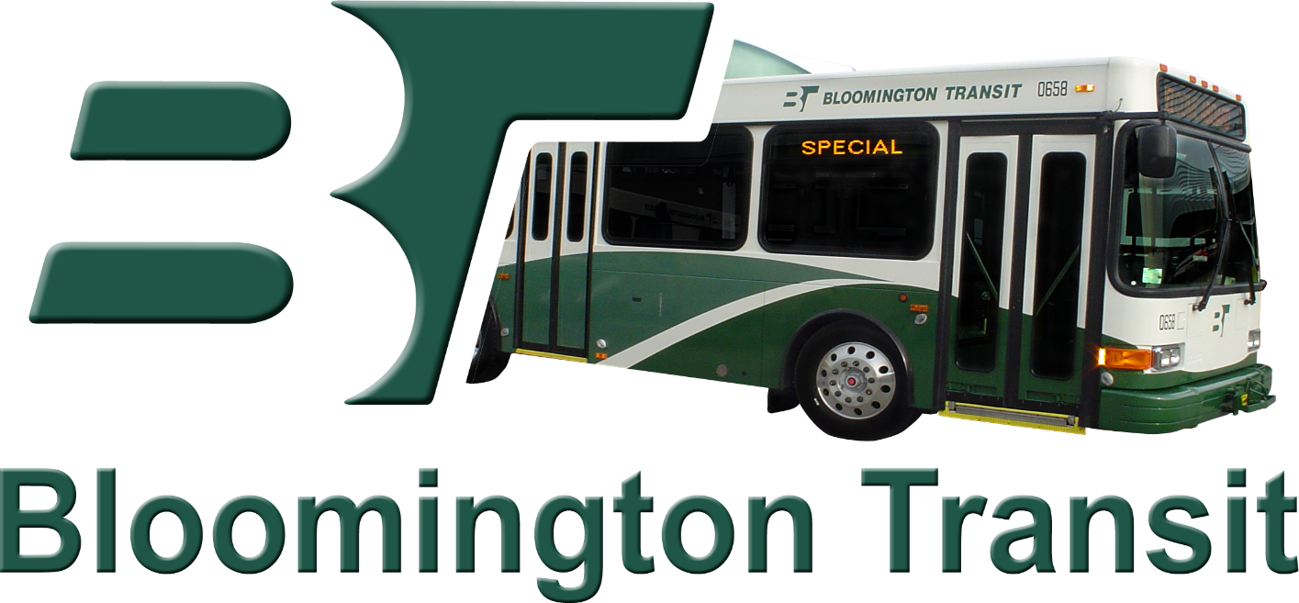

Bloomington Public Transportation Corporation
130 West Grimes Lane
Bloomington, IN 47403

OPERATING EXPENSES
Budget Class I |  |  |  | 2020 |  | 2019 |  | Percent
 |  |  |  | Proposed |  | Approved |  | Change
Salaries (Operators) |  |  |  | 3,001,545 |  | $ 2,951,215 |  | 1.71%
 |  | Fixed and BT Access full and part
 |  | time operators
Salaries (Other Operating) |  |  |  | 374,912 |  | 367,709 |  | 1.96%
 | Operations manager and supervisors;
 | and BT Access F/T dispatchers
Salaries (Maintenance) |  |  |  | 775,271 |  | 766,803 |  | 1.10%
 | Maintenance manager, mechanics,
 | service attendants, and parts
 | specialist salaries
Salaries (Other) |  |  |  | 490,094 |  | 503,323 |  | -2.63%
 | Administrative staff
FICA |  |  |  | 355,099 |  | 351,062 |  | 1.15%
PERF |  |  |  | 413,122 |  | 406,328 |  | 1.67%
Health/Dental/Disability/Life/Vision |  |  |  | 550,960 |  | 592,719 |  | -7.05%
 | Insurance
Unemployment |  |  |  | 10,000 |  | 10,000 |  | 0.00%
Employee Uniforms |  |  |  | 25,624 |  | 24,878 |  | 3.00%
Tool and CDL Allowance |  |  |  | 11,840 |  | 10,445 |  | 13.36%
Subtotal Budget Class I |  |  |  | $ 6,008,467 |  | $ 5,984,482 |  | 0.40%
Budget Class II |  |  |  | 2020 |  | 2019 |  | Percent
 |  |  |  | Proposed |  | Approved |  | Change
Office Supplies |  |  |  | 16,326 |  | $ 15,549 |  | 5.00%
Garage Uniforms/Drug Testing |  |  |  | 15,000 |  | 15,000 |  | 0.00%
Fuel/Oil/Grease/Fluids |  |  |  | 924,756 |  | 915,000 |  | 1.07%
Parts |  |  |  | 555,948 |  | 555,948 |  | 0.00%
Other Supplies |  |  |  | 125,364 |  | 125,364 |  | 0.00%
Subtotal Budget Class II |  |  |  | $1,637,394 |  | $1,626,861 |  | 0.65%
Budget Class III
Professional Services |  |  |  | 767,626 |  | $506,747 |  | 51.48%
 | Expenses include contracted
 | transit management services,
 | contracted facility maintenance
 | services, software support services, Microtransit
 | employee counseling services, downtown security,legal
 | services, information technology services,
 | payroll processing, and auditing services.
Telephone |  |  |  | 13,920 |  | 11,000 |  | 26.55%
Postage |  |  |  | 3,819 |  | 3,708 |  | 2.99%
Travel |  |  |  | 3,684 |  | 3,509 |  | 4.99%
Printing |  |  |  | 30,447 |  | 22,279 |  | 36.66%
Advertising |  |  |  | 39,327 |  | 30,900 |  | 27.27%
Insurance/Risk Management |  |  |  | 303,154 |  | 260,900 |  | 16.20%
Electricity |  |  |  | 60,000 |  | 60,000 |  | 0.00%
Budget Class III (continued) |  |  |  | 2020 |  | 2019 |  | Percent
 |  |  |  | Proposed |  | Approved |  | Change
Water |  |  |  | 12,000 |  | 12,000 |  | 0.00%
Gas |  |  |  | 15,500 |  | 15,500 |  | 0.00%
IU Shared Expenses |  |  |  | 140,137 |  | 110,000 |  | 27.40%
Building Maintenance |  |  |  | 20,000 |  | 20,000 |  | 0.00%
Repairs and Labor |  |  |  | 61,800 |  | 60,000 |  | 3.00%
Training, Dues, and Subscriptions |  |  |  | 40,000 |  | 43,800 |  | -8.68%
Subtotal Budget Class III |  |  |  | $1,511,414 |  | $1,160,343 |  | 30.26%
Total Operating Expenses |  |  |  | $9,157,275 |  | $8,771,686 |  | 4.40%
Budget Class IV - Capital
Tires and Engine/Transmission Rebuilds |  |  |  | 204,725 |  | $196,851 |  | 4.00%
Equipment and Maintenance |  |  |  | 613,250 |  | 516,700 |  | 18.69%
 | Includes computer hardware and software,
 | Facility maintenance, Automatic passenger counters
Motor Equipment - 4 buses |  |  |  | 4,000,000 |  | 1,000,000 |  | 300.00%
Subtotal Budget Class IV |  |  |  | $4,817,975 |  | $1,713,551 |  | 181.17%
TOTAL EXPENDITURES |  |  |  | $13,975,250 |  | $10,485,237 |  | 33.29%
Revenues |  |  |  | 2020 |  | 2019 |  | Percent
 |  |  |  | Proposed |  | Approved |  | Change
Property Tax Levy |  |  |  | $1,356,945 |  | $1,311,058 |  | 3.50%
Financial Institution Tax |  |  |  | 11,870 |  | 10,822 |  | 9.68%
License Excise Tax |  |  |  | 61,290 |  | 58,753 |  | 4.32%
Local Option Income Tax |  |  |  | 512,037 |  | 501,997 |  | 2.00%
Commercial Vehicle Excise Tax |  |  |  | 3,666 |  | 4,021 |  | -8.83%
Passenger Fares |  |  |  | 630,000 |  | 600,000 |  | 5.00%
Advertising Sales |  |  |  | 130,000 |  | 85,000 |  | 52.94%
State PMTF |  |  |  | 2,549,423 |  | 2,521,684 |  | 1.10%
Federal -Operating and Capital |  |  |  | 6,289,950 |  | 3,663,530 |  | 71.69%
MPO Planning |  |  |  | 0 |  | 34,000 |  | -100.00%
Transfer from Operating Reserve |  |  |  | 899,845 |  | 377,640 |  | 138.28%
IU Contract Revenue |  |  |  | 1,240,087 |  | 1,111,732 |  | 11.55%
IU Reimbursements |  |  |  | 140,137 |  | 110,000 |  | 27.40%
Miscellaneous |  |  |  | 150,000 |  | 95,000 |  | 57.89%
TOTAL REVENUE |  |  |  | $13,975,250 |  | $10,485,237 |  | 33.29%

